Wayne County Extension and Community Association
Community Service Award Guidelines
Categories and Judging Criteria
Form Due: December 7th, 2018

Bronze Award:
To receive the bronze award, a club must:
- complete a minimum 3 community service projects
- 50% of club members must have been involved at some time throughout the year, not for each project
- club must average 10 hours of service per member

Silver Award:
To receive the silver award, a club must:
- complete minimum of 3 community service projects
- 60% of club members must have been involved at some time throughout the year, not for each project
- club must average 15 hours of service per member

Gold Award:
To receive the gold award, a club must:
- complete a minimum of 3 community service projects
- 75% of club members must have been involved at some time throughout the year, not for each project
- club must average 20 hours of service per member

** In order to receive the award for any category ALL criteria for each must be met

Procedure

Clubs will need to turn in the following information:
- Name of each project
- Number of members who worked on at least one project
- Total number of hours club members worked on project (for example: 4 members worked 6 hours each for a total of 24 hours and 5 members worked 2 hours each for a total of 10 hours giving a grand total of 24 +10 =24 hours)

Volunteer time given to on-going service (like soup kitchen)
as well as for projects completed will be counted.

The following will be completed by the Extension office:

The percentage of members involved in community service will be determined by dividing the number of members who actively participated in at least one project by the number of members in a club. For example: Club A has 18 members. 12 of them participated in community service on behalf of the club. 12 divided by 18 is .67 or 67%. Thus 67% of the members participated which puts the club in the silver category. Average number of service hours will be determined by taking the total number of hours volunteered by a club and dividing by their total number of members. For example: Club A volunteered 2000 hours. They have 20 members. 2000 divided by 20 is 200. This more than meets the criteria for the gold category.

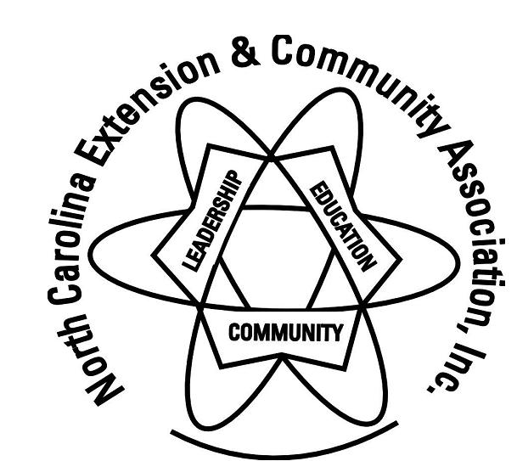
Wayne County Extension and Community Association

2018 Community Service Recognition Form

Club: _______________________________________

Number of Members: __________________

Name of project: | Number of members involved: | Total number of hours:
Total:

