Report for Year 2018
[___] December - May or [___] June - November
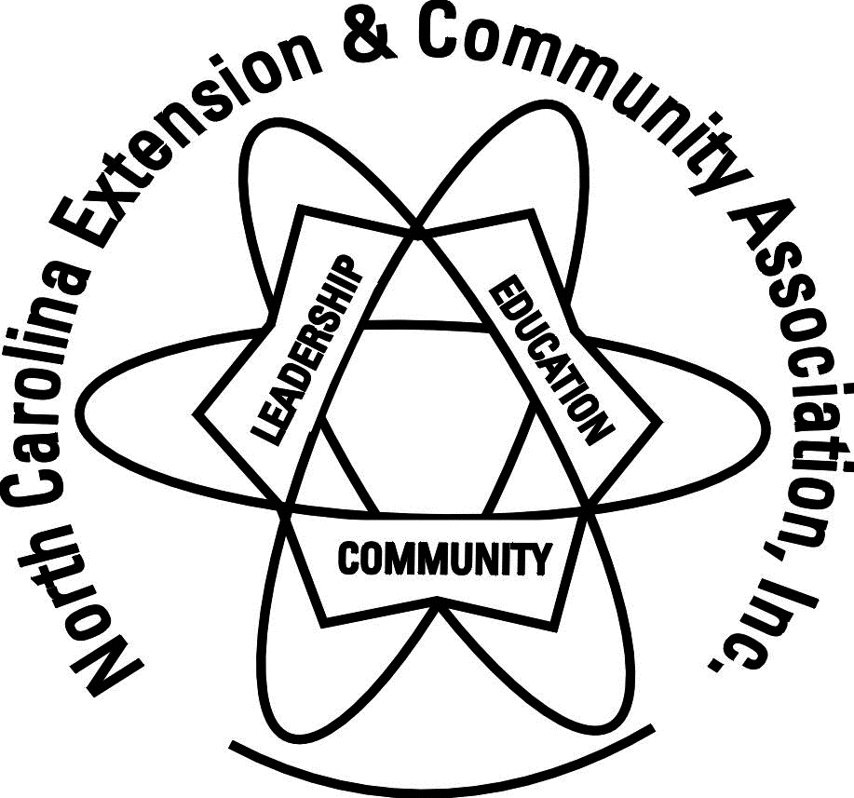

[ ] Individual [ ] ____________________Club [ ] County: Wayne __

Name: ___________________ Phone Number: _______________ E-mail: ________________

Liaison Agent Michelle Estrada

# Members ____ # Clubs ___ # New Members ___

In each area below, please report your participation/ accomplishments. Use additional sheets if needed!

Leadership (Leading others, holding office, planning, teaching, etc.)
Name of program, project, event, activity, etc. | Volunteer Hours  ECA Other |  | Number  reached | Actual Dollars  Spent Contributed
Achievement Luncheon
Area Meetings
Club Meetings
Committee Meetings
County Council
District Meetings
Finance Meetings
Leadership Meetings
Monthly pre-caller hostess
State Meetings
Club Buildings Administration and Maintenance (hbest2011@nc.rr.com)
President, Secretary and Treasurer Duties
Total:

Education (Participating in a learning opportunity, etc.)
Name of program, project, event, activity, etc. | Volunteer Hours  ECA Other |  | Number  reached | Actual Dollars  Spent Contributed
Books for Children
Box Tops for Schools (How many? 653)
Educational Programs
Educational Trips
Extension Programs
International Luncheon
Rose Banquet
Scholarships Clubs (Total amount? $1666)
School Parties
School Supplies
Soup Labels for Schools (How many? 234)
Tutoring
Other
Total:

Community Service
Name of program, project, event, activity,  or items donated etc. | Volunteer Hours  ECA Other |  | Number  reached | Actual Dollars  Spent Contributed
Donations:
Baby Layettes (How many? 29)
Bibs for Edgewood School (How many? 110)
Canned food
Club Activities, Fund Raisers
Donation to Boys and Girls Home
Donation to Chemo Dept.
Donation to Disasters
Donation to Operation Christmas Child
Donation to Ronald McDonald House
Donation to Victory Junction
Donations to Family and Friends
Donations to Salvation Army
Donations to Soup Kitchen
Eye Screeners for Schools (How many?3012)
Food and Visits for Sick Members
Grocery bags for Edgewood School
Hygiene and Personal Items
Magazines for Hospitals, Nursery Homes,
Meals on Wheels (Goodie Bags, baskets, etc.)
Pennies for Angels
Pennies for Friendship
Samaritan's Purse Boxes
Snacks for Hospital, Nursery homes
Tabs for Ronald McDonald (How many? 52Lbs.)
Teddy Bears for Hospital (How many? 120)
Bag Packs FLOK
Adopted Child in Africa
Project Uplift
Power of Girls
Empty Stacking Fund
Cancer Patient
School Fundraiser
Church Activities
Fire Department
Pregnancy Center
Cures for Colors
Donation St. Baldricks’ Children Center Research
Mission Trip
Pillow Cases Dresses
Shoes for Children
Make a Difference Food Pantry
Hospital /Nursery Homes
WAGES
Thanks Giving Baskets
Other Activities
Total:

Communications & Marketing
Name of program, project, event, activity, etc. | Volunteer Hours  ECA Other |  | Number  reached | Actual Dollars  Spent Contributed
Christmas Bazaar
ECA Quilt
Farm City Banquet
Friendship Event
News Articles
Soup and Sandwich
Wayne County Fair
Cultural Arts
Power of Girls
Total:

Totals from ALL listed above:

Volunteer Hours: # ECA _______
Number Reached ___________
Contributions:
# Other _______
Dollars Spent ____________ Donated: ____________
Items Donated: # $
Total $ value of contributions ________________

Club & County Report Only!
Does your county have?
a newsletter? Yes [ ] No [ ] Electronic? Yes [ ] No [ ] Number per year:
a marketing brochure? Yes [ ] No [ ]
a facebook page? Yes [ ] No [ ]

Does your club or county give scholarships? Yes [ ] No [ ]
If yes, number and amount, (i.e. 2 @ $500)
When and who for submission

July 1: Submit individual (for CVU) and county form to NCECA VP - Reports and Recognition
CVU (hours brought forward)

June 1 & Submit individual forms to club president so she/he can compile club report
December 1

June 15 & Presidents submit club forms to council president and liaison agents (for County
December 15 recognition and liaison agent Accomplishment Reports)

Membership Ideas: Explain what activity was tried, was it successful, what would you change?

Share a speaker or program. Please share name and contact information of a speaker, program or project your county enjoyed this year.

Name Phone ( ) Email

Address

3@ $150
1@ $500

